A2621-Eur-Cyprus-Asclepius-Bearded Bust with His Staff -Terra cotta-c 50 CE

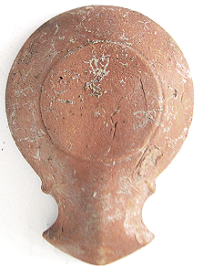

Figs. 1-2. Eur-Cyprus-Asclepius-Bearded Bust with His Staff -Terra cotta-c 50 CE

**Case no.: 4**

**Accession Number: A2621**

**Formal Label:** Eur-Cyprus-Asclepius-Bearded Bust with His Staff -Terra cotta-c 50 CE

**Display Description:**

This is a red terra cotta oil lamp, 1st century CE, honoring Asklepios, with a small oil filler-hole positioned towards the volute nozzle. Asklepios was a revered Greek medical doctor in the time of the Peloponnesian Wars in the 6th century BCEwith his four daughters Hygieia ("Health"), Iaso ("Medicine"), Aceso ("Healing"), and Panacea ("Universal Remedy"). An unusual Roman copy of a Greek original sculpture of the youthful Asklepios was deposited in the Vatican.

After the Peloponnesian Wars and his death in the early 5th century BCE Asklepios was elevated to the level of a deity (as was common among Greek sages) along with his daughters.

This lamp was used by a patient in the *abaton* or sleeping chamber of the Asklepieion or hospital on Cyprus. The center of the discus is decorated with the bearded bust of Asklepios and, to the right, is his *baton de commandement*, a crutch with a cross-piece which is clearly visible, called the **asklepian** entwined around which isa single snake. The serpent signifies the rôle of serpents as agents of cleanliness as they were allowed to circulate among the patients in the *abaton* or hospital sleeping chambers of the ill during the evening in order to consume vermin orany other infectious pests. The crutch signified the healing power of Asklepios where crutches and other votive objects like terra cotta figurines of infected body parts were deposited in the Asklepieion or hospital precincts venerating the cures that were effected by him.

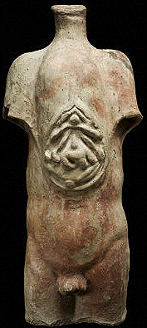

Fig. 5. A Roman terra cotta votive torso recording the healing of Asklepios on an ailment of the liver and gall bladder, *c* 200 BCE*.* Science Museum, London. Wellcome Images



Fig. 4. Restored statue of a bearded Asklepios after his deification in the 5th c BCE

now exhibited in the Epidauros Museum. After a photograph by Michael F. Mehnert, 2008,

File:Asklepios - Statue Epidauros Museum 2008-09-11.jpg

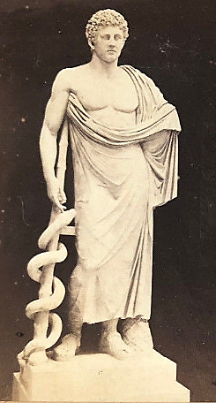

Fig. 3. Statue of a youthful, beardless Asklepios of a 6th c BCE copy of the Greek original in the Vatican Museum c 1860 in a stereo view by Libreria Spithover, 85 Piazza di Spagna, Roma.

Probably, this oil lamp was used at the Asklepieion in Salamis, Cyprus, where Hadrianic period statues of Asklepios and Heigeia have been excavated. Unfortunately their heads had been destroyed by either Christians under Constantius II or by the Muslim conquest in the 7th c CE.

[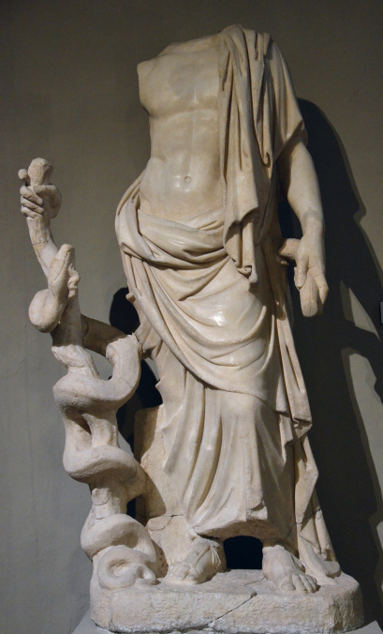](https://followinghadrian.com/2015/11/09/wandering-along-the-colonnade-of-the-gymnasium-of-salamis-cyprus/21875082364_d25303a133_h/)[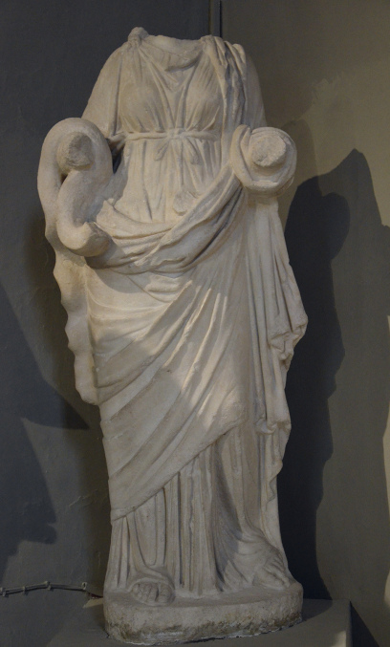](https://followinghadrian.com/2015/11/09/wandering-along-the-colonnade-of-the-gymnasium-of-salamis-cyprus/22497796245_99f35ab6bc_h/)

Statues of Asklepios (Fig. 6) and Hygeia Fig. 7) from the Asklepeion at Salamis now in the Cyprus Museum, Nicosia. Salamis was destroyed by earthquakes c 350 CE but was quickly rebuilt as a Christian city by the Byzantine emperor Constantius II (317-361 CE), who renamed the city Constantia. Salamis was finally abandoned during the 7th c Arab invasions of [Muawiyah I](https://en.wikipedia.org/wiki/Muawiyah_I). (Karageorghis 1969; Mitford & Nicolaou 1974).

In the 3rd century BCE, when plagues were endangering Rome’s population, a request was sent to Pergamum to establish an Asklepieion on Rome’s Tiber River Island. In Rome Asklepios’ name was Latinized as “Asclepius”, and among Roman Etruscans he was associated with their deified healer, Vediovis. Even the Romans considered Vediovis as an ancient indigenous healer. Vediovis’ hospital was located on the slope of the Capitoline Hill, where Romulus, another Etruscan healer, who was considered with Remus as one of the founders of Rome, had previously opened his asylum. The festival celebrating Vediovis was on March 7, while the festival celebrating Asclepius was on the island of Tiber on January 1st.

**LC Classification:** BL820.A4

**Date or Time Horizon:** 5th c BCE

**Geographical Area:** Cyprus

**Map:**

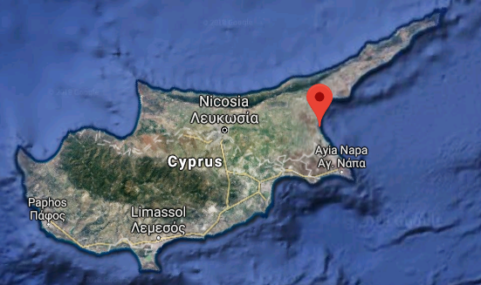

**Map of Cyprus showing location of Salamis.**

**After https://www.google.com/maps/place/35°11'00.0"N+33°54'00.0"E/**

**GPS coordinates:** [35°11′N 33°54′E](https://tools.wmflabs.org/geohack/geohack.php?pagename=Salamis,_Cyprus&params=35_11_N_33_54_E_type:landmark)

**Cultural Affiliation:** Cyprus

**Medium:** terra cotta

**Dimensions:** L 9.9 cm, 3.9 in

**Weight:**

**Condition: original**

**Provenance:** Cyprus

**Discussion:**

A 5th c altar dedicated to Vediovis was found near Alba, in Bovillae, which proves that he was honored by the Julia family, one of the most ancient Roman patrician families thatattained the Republic’s highest dignities, as its founder: "To Vediovis, father, members of the Iulian clan” (Weinstock 1971). Of the Julia family notables were Gaius Julius Iulus, who became a consul in 489 BCE, and Gaius Julius Caesar, who became dictator in 49 BCE.

**References:**

Karageorghis 1969;

Mitford & Nicolaou 1974).

**Appendix:**

**The shape of this lamp is identical to another one from Cyprus featuring Luna, goddess of the moon.**

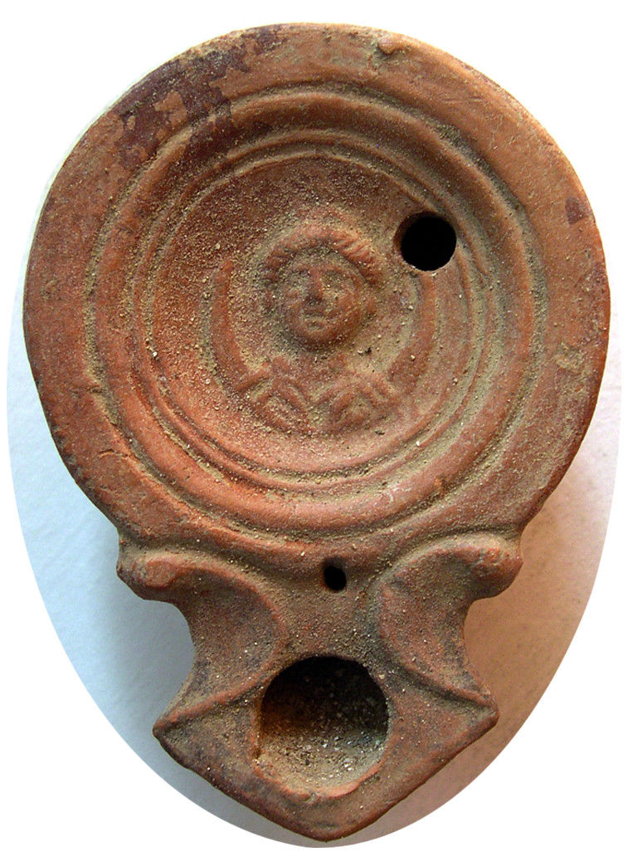

### After parscoins PCW-AN289-**ROMAN EMPIRE. Circa 2nd-3rd. Century AD. Terracotta Oil Lamp. (48.08 gm; 80mm; 56mm; 25mm). Depicting Luna, Goddess of the Moon.**

**References:**

Karageorghis, Vassos. 1969**. *Salamis in Cyprus: Homeric, Hellenistic and Roman*. London: Thames and Hudson.**

Mitford, Terence Bruce and Ino K Nicolaou. 1974. ***The Greek and Latin inscriptions from Salamis.*** Nicosia: Department of antiquities

Weinstock, S. 1971. Divus Julius. Oxford: Oxford University Press.